Given an undirected tree consisting of n vertices numbered from 0 to n-1, which has some apples in their vertices. You spend 1 second to walk over one edge of the tree. *Return the minimum time in seconds you have to spend to collect all apples in the tree, starting at****vertex 0****and coming back to this vertex.*

The edges of the undirected tree are given in the array edges, where edges[i] = [ai, bi] means that exists an edge connecting the vertices ai and bi. Additionally, there is a boolean array hasApple, where hasApple[i] = true means that vertex i has an apple; otherwise, it does not have any apple.

**Example 1:**

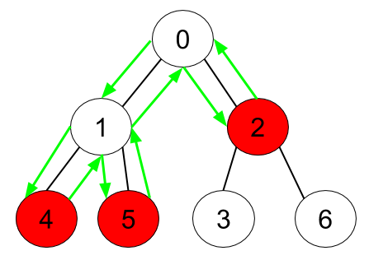

**Input:** n = 7, edges = [[0,1],[0,2],[1,4],[1,5],[2,3],[2,6]], hasApple = [false,false,true,false,true,true,false]

**Output:** 8

**Explanation:** The figure above represents the given tree where red vertices have an apple. One optimal path to collect all apples is shown by the green arrows.

**Example 2:**

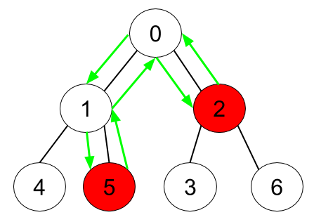

**Input:** n = 7, edges = [[0,1],[0,2],[1,4],[1,5],[2,3],[2,6]], hasApple = [false,false,true,false,false,true,false]

**Output:** 6

**Explanation:** The figure above represents the given tree where red vertices have an apple. One optimal path to collect all apples is shown by the green arrows.

**Example 3:**

**Input:** n = 7, edges = [[0,1],[0,2],[1,4],[1,5],[2,3],[2,6]], hasApple = [false,false,false,false,false,false,false]

**Output:** 0

**Constraints:**

* 1 <= n <= 10^5
* edges.length == n - 1
* edges[i].length == 2
* 0 <= ai < bi <= n - 1
* fromi < toi
* hasApple.length == n